Healthcare Data Integration and Analysis - Submission
This template helps you capture and share screenshots of your code and results for each task.

Instructions
- Insert value or screenshots showing the relevant output and code, as mentioned in the tasks of the project.
- If one screenshot cannot clearly show both code and output, use two screenshots placed one after the other.
- Ensure all screenshots are readable.
- You can share the screenshots in any of the following formats: .png, .jpg, .jpeg, .jfif, .webp, .bmp, .tiff, .tif

Task 1: Import the data sets from text files into spreadsheet format
Task | Activity name | Screenshot of both the code and output
1a | Screenshot of Pharmacy_Claims.xlsx | 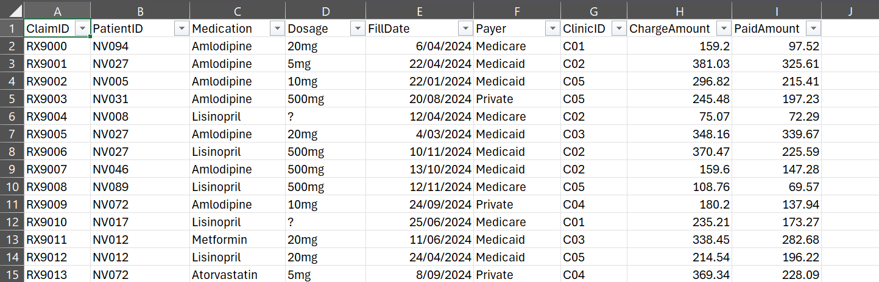
1b | Screenshot of Lab_Results.xlsx | 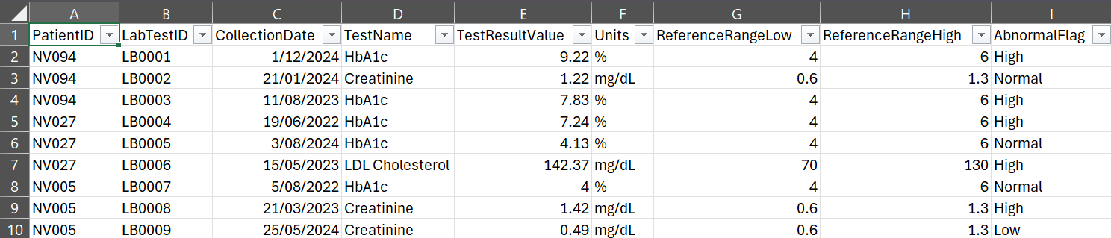

Task 2: Analyze the data sets using Excel
Note: For AI evaluation purposes, do NOT include units or any additional text —only provide the numeric value.
2.1a | Considering the Pharmacy_Claims data set, how many paid amounts exceed $250? | 21
2.1b | Considering the Pharmacy_Claims data set, which payer has paid the highest amount? | Medicaid
2.1c | Considering the Pharmacy_Claims data set, what is the total amount paid by the payer identified in part 2.1b. | 6180.81
2.2a | Based on the Lab_Results data set, what is the top result within the LDL Cholesterol test. | 187.1
2.2b | Based on the Lab_Results data set, what is the average value for the LDL Cholesterol test? | 134.6391
2,2c | Based on the Lab_Results data set, how many patients have high LDL Cholesterol (> 160 mg/dL)?? | 12

Task 3: Identify and fix the issues in a data set using Python
Activity number | Activity name | Screenshot
3.1a | Write the Python code to identify the number of missing values. | missing_values = df.isnull().sum()  print("Missing values by column:")  print(missing_values)  print("\nTotal missing values in dataset:")  print(df.isnull().sum().sum())
3.1b | Write the Python code to identify the number of duplicate values. | # Count duplicate rows  duplicate_rows = df.duplicated().sum()  print("Number of duplicate rows:")  print(duplicate_rows)  # Display duplicate rows if any  df[df.duplicated(keep=False)]
3.1c | Write the Python code to identify inconsistent categorical entries in the Gender column. | # Check all unique values in Gender column  print("Unique values in Gender column:")  print(df["Gender"].unique())  # Count each Gender entry  print("\nGender value counts:")  print(df["Gender"].value_counts(dropna=False))
3.1d | Write the Python code to identify inconsistent date formats in the AdmissionDate column. | # View unique AdmissionDate values  print("Sample AdmissionDate values:")  print(df["AdmissionDate"].head(20))  # Try converting AdmissionDate to datetime  converted_dates = pd.to_datetime(df["AdmissionDate"], errors="coerce", infer_datetime_format=True)  # Count dates that could not be converted  invalid_dates = converted_dates.isnull().sum()  print("Number of inconsistent or invalid AdmissionDate values:")  print(invalid_dates)  # Display rows with invalid AdmissionDate values  df[converted_dates.isnull()]
3.2a | Write the Python code to handle missing values appropriately. | # 3.2a Handle missing values appropriately  # Fill missing DateOfBirth values with 'Unknown'  df["DateOfBirth"] = df["DateOfBirth"].fillna("Unknown")  # Fill missing ZipCode values with 'Unknown'  df["ZipCode"] = df["ZipCode"].fillna("Unknown")  # Check missing values after handling  print("Missing values after cleaning:")  print(df.isnull().sum())
3.2b | Write the Python code to remove exact duplicate rows. | # 3.2b Identify and remove exact duplicate rows, keeping only the first occurrence  # Count duplicate rows before cleaning  print("Number of duplicate rows before cleaning:")  print(df.duplicated().sum())  # Display all duplicate records, including the first occurrence  duplicate_records = df[df.duplicated(keep=False)]  print("\nDuplicate records:")  display(duplicate_records)  # Remove exact duplicate rows, keeping only the first occurrence  df = df.drop_duplicates(keep="first")  # Check duplicates after removal  print("\nNumber of duplicate rows after cleaning:")  print(df.duplicated().sum())
3.2c | Write the Python code to standardize gender values. | # 3.2c Standardize Gender values  df["Gender"] = df["Gender"].astype(str).str.strip().str.lower()  df["Gender"] = df["Gender"].replace({  "m": "Male",  "male": "Male",  "f": "Female",  "female": "Female"  })  # Check Gender values after standardisation  print("Gender values after standardisation:")  print(df["Gender"].value_counts())
3.2d | Write the Python code to standardize date values. | # 3.2d Standardize AdmissionDate values without creating an original column  # Clean AdmissionDate as text  date_col = df["AdmissionDate"].astype(str).str.strip()  # Convert possible Excel serial dates to numeric  numeric_dates = pd.to_numeric(date_col, errors="coerce")  # Identify Excel serial dates such as 45258 or 45439  is_excel_serial = numeric_dates.notna()  # Create empty datetime series  standardized_dates = pd.Series(pd.NaT, index=df.index)  # Convert Excel serial dates  standardized_dates.loc[is_excel_serial] = pd.to_datetime(  numeric_dates.loc[is_excel_serial],  unit="D",  origin="1899-12-30",  errors="coerce"  )  # Convert normal date strings, e.g. 07-06-2024  standardized_dates.loc[~is_excel_serial] = pd.to_datetime(  date_col.loc[~is_excel_serial],  dayfirst=True,  errors="coerce"  )  # Save standardized dates back to AdmissionDate  df["AdmissionDate"] = standardized_dates.dt.strftime("%Y-%m-%d")  # Check results  print("AdmissionDate after standardisation:")  print(df[["PatientID", "AdmissionDate"]].head(20))  print("\nInvalid or missing AdmissionDate values after conversion:")  print(df["AdmissionDate"].isnull().sum())

Task 4: Analyze the data sets using SQL
Activity number | Activity name | Screenshot
4a | Write an SQL query to list all patients born before 1980. | run_query("""  SELECT *  FROM patients  WHERE DATE(DateOfBirth) < '1980-01-01';  """)
4b | Write an SQL query to list all female patients with Type 2 Diabetes. | run_query("""  SELECT  *  FROM patients  WHERE Gender = 'Female'  AND PrimaryCondition LIKE '%Type 2 Diabetes%';  """)
4c | Write an SQL query to display all lab tests performed. List each patient (PatientID, Gender, and DateOfBirth from patients) with their lab test name and result value (TestName and TestResultValue from lab_results). | run_query("""  SELECT  p.PatientID,  p.Gender,  p.DateOfBirth,  l.TestName,  l.TestResultValue  FROM patients p  JOIN lab_results l  ON p.PatientID = l.PatientID;  """)
4d | Write an SQL query to display all distinct patients with their payer(s). List each patient (PatientID, Gender, DateofBirth from patients) with their payer(s) from the pharmacy_claims data set. | run_query("""  SELECT DISTINCT  p.PatientID,  p.Gender,  p.DateOfBirth,  pc.Payer  FROM patients p  JOIN pharmacy_claims pc  ON p.PatientID = pc.PatientID;  """)

